Temperature Sensor

Aim : To detect temperature using a sensor and glow blue, green, or red LED according to the temperature range.

Circuit: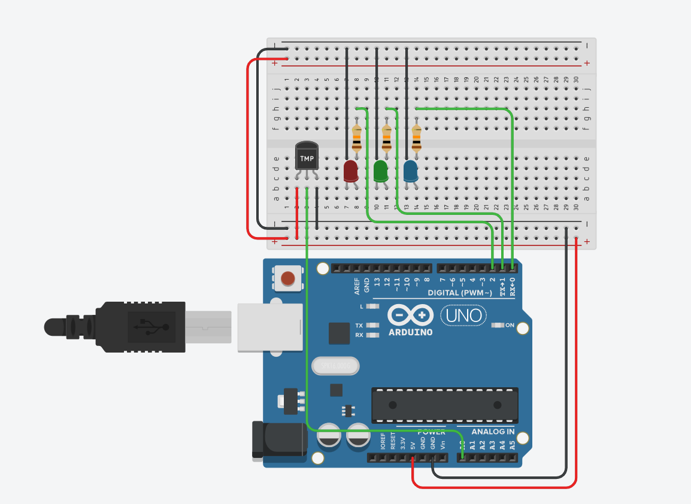

Code :
const int blue = 0;
const int green = 1;
const int red = 2;

void setup() {
pinMode(A0, INPUT); // Temperature sensor
pinMode(blue, OUTPUT);
pinMode(green, OUTPUT);
pinMode(red, OUTPUT);
}

void loop() {
int sensor = analogRead(A0);
float voltage = (sensor / 1024.0) * 5.0;
float tempC = (voltage - 0.5) * 100; // For TMP36 sensor

// ---------------- Conditions ----------------
if (tempC < 25) {
// BLUE ON
digitalWrite(blue, HIGH);
digitalWrite(green, LOW);
digitalWrite(red, LOW);
}
else if (tempC >= 25 && tempC <= 40) {
// GREEN ON
digitalWrite(blue, LOW);
digitalWrite(green, HIGH);
digitalWrite(red, LOW);
}
else {
// RED ON (temp > 40)
digitalWrite(blue, LOW);
digitalWrite(green, LOW);
digitalWrite(red, HIGH);
}

delay(200); // small delay for stability
}

Observation :
As the temperature changes, the LED color changes correctly: the blue LED glows below 25°C, the green LED glows between 25°C and 40°C, and the red LED glows when the temperature rises above 40°C.

